Sunrise Summer Enrichment Program 2020

This summer we’re offering the Sunrise Summer Enrichment Camps that have weekly themes developed by our teaching staff for your children. The camps will begin on June 8 and continue through August 7th. Hours will be from 8:30-3:30, Monday-Friday with Early Care (Optional) from 7:30-8:30 and Aftercare (Optional) from 3:30-5:30.

We are offering Sunrise families a registration discount. Since we have limited enrollment based on licensure requirements and available space, we prioritize our Sunrise families whose children are between ages 3 to 8 years. Registration will however be on a first come basis.

Sunrise Summer Enrichment Program Registration and Tuition Rates
Early Bird SLC Family Registration and Materials Fees:  $50 if paid by May 1 for SLC families.  General Registration for New Families: $75 if paid by May 1.  After May 1, Registration is $100. | 5 Day Weekly Tuition Option per child  June- 8 -Aug.7= $1750  Weekly Rate: $225 per child | 3 Day Weekly Tuition Option  June 8-Aug.7=$845  Weekly Rate: $150 per child | All tuition payments due during 1st week of the month.  June Tuition due the week of June 8th  July Tuition due the week of July 3  August Tuition due the week of Aug. 3
Early Care:  7:30-8:30 AM  After Care:  3:30-5:30 PM | June Payment due by  July 3 | July Payment due by  Aug. 3 | August payment due August 9

Dates: Weekly Themes and Descriptions Faculty
Week 1: 6/8-6/12 | Physical Fitness: is an important part of child development and overall health. During this week of camp, we will explore games from the past and present as well as come up with some of our own. Relay races, solving puzzles, and games await everyone! | Ms. Lindsey and Assistants
Week 2-3  6/15-26 | Animal Weeks: we will explore animals of the present as well as the past. What is an endangered species? Why can't you have an elephant for a pet? Children will learn the different lifestyles of animals from all over the world through books, projects, plays, and more.  We may even have some visits by exotic as well as domestic animal visitors! | Ms. Lindsey and Assistants
Week 4: 6/29-7/3 | Busy Hands are Happy Hands: What kind of work do your parents do? What would you like to do when you grow up? We will explore the different kinds of work that are available? We will have visitors from the working community and have some fun volunteer activities as well. | Ms. Lindsey  And Assistants
Week 5: 7/6-7/10 | Myths to Monsters: We will explore Greek and Norse myths and how they inform our own myths today. Together we will take an adventure through different stories, fables and legends from diverse cultures and explore them through art, games, and more. We may even write our own myths! | Ms. Lindsey And Assistants
Week 6: 7/13-7/17 | Space, the Endless Frontier: Students will dive into the frontiers of space this week! We will explore the earth's atmosphere and travel all the way to the outer reaches of our solar system. Comets, planets, stars, are just waiting to be discovered! | Ms. Lindsey  And Assistants
Week 7: 7/20-7/24 | Earth Week: This week will be a fun, exciting, and educational as we explore the earth by staring right where we live. We will discuss many unique environmental themes. Topics will range from wildlife studies to river and watershed exploration. | Ms. Lindsey  And Assistants
Week 8: 7/27-7/31 | The World through Rose-Colored Lenses: Campers will explore color through art techniques, learn about famous artists, and express themselves creatively in a myriad of different ways! | Ms. Lindsey  And Assistants
Week 9:  8/3-8/7 | The Day of the Dinosaur: Campers will journey to discover what the earth was like when the dinosaurs roamed. How did they evolve? What did they eat? What happened to them? We will hunt for buried fossils, create our own dinosaurs, and read some stories about them too. | Ms. Lindsey  And Assistants

Please return pages 4-6 with deposit to reserve your child’s place in the program. Registration is on a first come first serve basis and will be limited by the space available in the program.

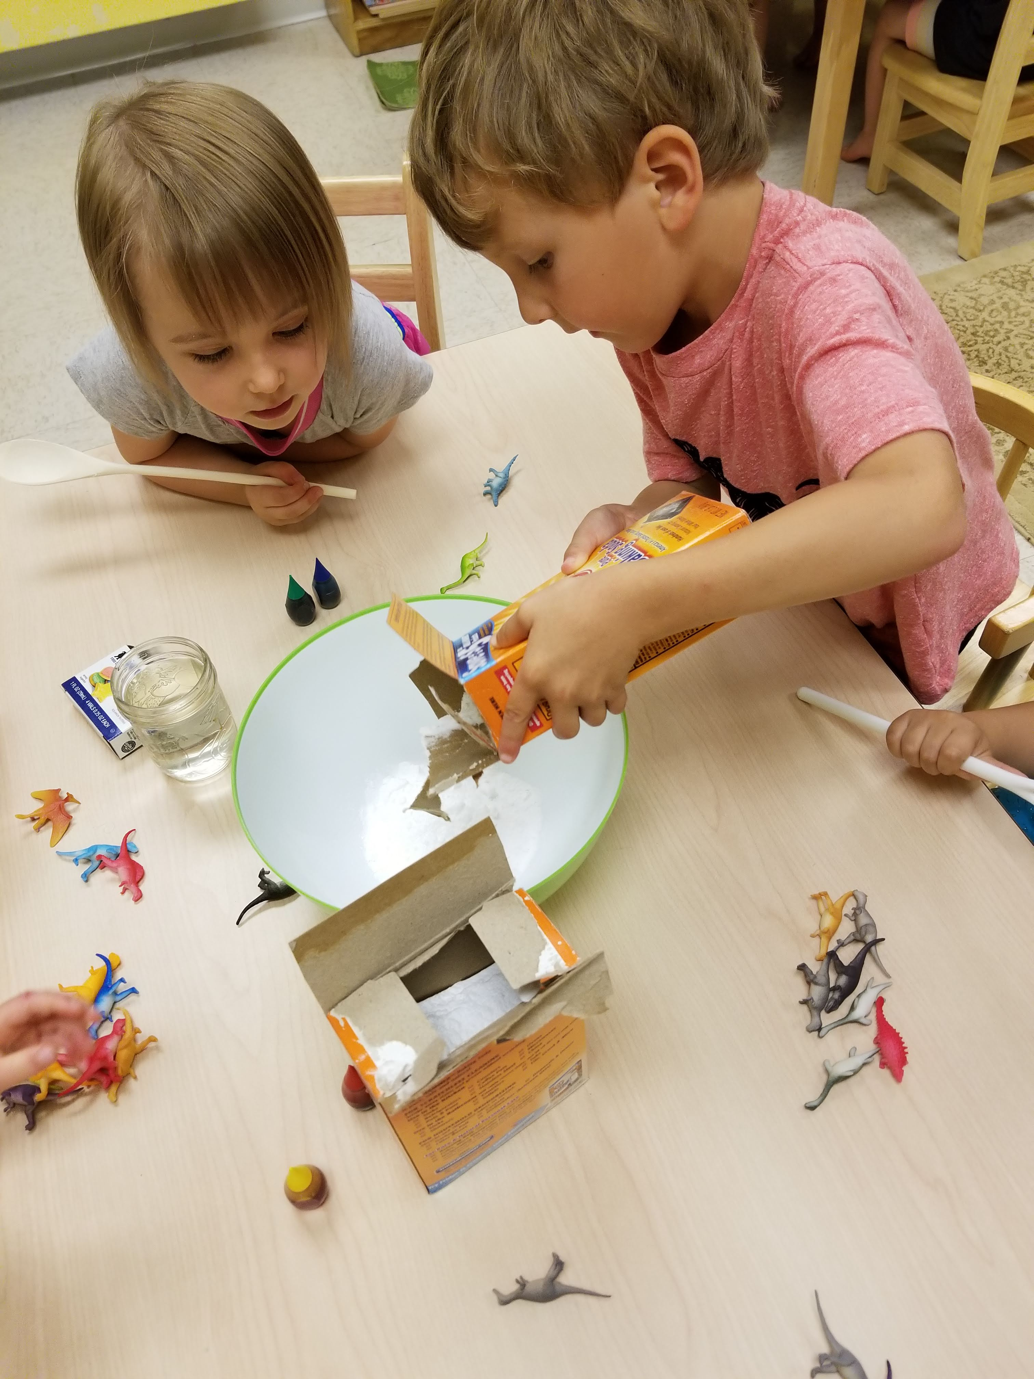

Sunrise Summer Enrichment Registration Form

The Sunrise Learning Center admits students of any race, color, national origin, and ethnic origin to all the rights, privileges, programs, and activities generally accorded or made available to students at the school. It does not discriminate on the basis of race, color, national origin, sexual orientation, gender, and ethnic origin in administration of its educational policies, admission policies, scholarship and loan programs, and athletic and other school-administered programs.

Child’s Full Name:_________________________________________________

2nd Child’s Full Name:_______________________________________________

3rd Child’s Full Name:_______________________________________________

1st Child’s Date of Birth/Age:__________ years _________months Gender:______________
2nd Child’s Date of Birth/Age:__________years _________months Gender:_____________
3rd Child’s Date of Birth/Age:__________ years _________months Gender:______________

Home Address:_________________________________________________________________

City:_______________________________________________________Zip:_______________

Main Phone Contact Number(s):__________________________________________________

Preferred Email Contact: ____________________________________________________

Would you like to receive Text Messages: Yes __________ No__________

Medical Information:
Allergies: (list)
Immunization Records: | Bring copy to school
Other medical conditions. | Send in writing to school
Medical Consent: I give my consent for emergency treatment or care, to be used only if I or emergency contacts cannot be reached immediately:
Signature:____________________________________________________Date:___________

Parental Contact Information
Father’s Name: | Mother’s Name:
Home Address: | Home Address:
City:  Zip: | City:  Zip:
Occupation | Occupation
Phone: Home: | Phone: Home:
Cell: | Cell:
Office Phone: | Office Phone:
Email:  For announcements,  invoices, snow closings, etc. | Email:
Name of Persons Authorized to pick up your child:(Must have copies of driver’s licenses)

Two Persons to be notified in case of emergency, if parent not available:
Name/ Relationship:  Street Address: | Phone:
Name/ Relationship:  Street Address of 2nd Person: | Phone:
Name of Physician | Phone:
Please indicate below which weeks you would like to register each child for this summer and return this with the registration fee to: Sunrise Summer Enrichment Camps.

Full Summer Registration (Single Payment)
Cost for 5 Days | $1750
Cost for 3 Days | $845

Weekly Summer Registration Payment Due at Beginning of the Month

Weeks 5 Day Program Rate 3 Day Program Rate Check Choices Below
Week 1 June 8-12 | $225 | $150
Week 2 June 15-19 | $225 | $150
Week 3 June 22-26 | $225 | $150
Week 4 Jun 29- July 3 | $225 | $150
Week 5 July 6-10 | $225 | $150
Week 6 July 13-17 | $225 | $150
Week 7 July 20-24 | $225 | $150
Week 8 July27-31 | $225 | $150
Week 9 Aug.3-7 | $225 | $150

Early and After Care Options Check Choices Below
Option 1 | $5.00 an hour
Option 2 | $100 a month for both  Early Care and After Care
Not Needed

Please fill out the form and return drop it with the registration fee at school door envelope or mail to:
Sunrise Summer Enrichment Program
Hood Frazier
71 Sunrise Lane, Rice, VA 23966

2 Healthy Snacks, a water bottle and a lunch should be provided by parents daily.

